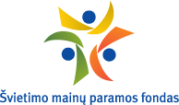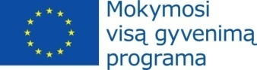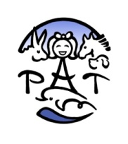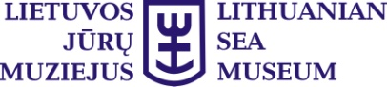
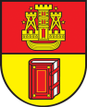

Scientific Conference "Invisible Powers of Nature"
Dolphin Assisted Therapy Center
Lithuanian Sea Museum
Smiltynės Str. 4, Klaipėda

9.30 - 10.00 opening of the conference
Mrs. Olga Žalienė, director of the Lithuanian Sea Museum
Representative of the Ministry of Health of the Republic of Lithuania
Representative of the Lithuanian Healthy Living and Alternatyve Medicine Organization
Representative of the Ministry of Social Protection of the Republic of Estonia
Representative of the Education Exchanges Support Foundation
10.00-10.15 "Reglamentation of Complementary and Alternative Medicine in Lithuania". Giedrė Kavaliauskienė, M.D., Klaipėda University, Lithuania.

10.15-10.30 "Formation of Rehabilitation Cluster for Children of North-Western Lithuania. Process and Initial Results". Žilvinas Malinauskas, Ph.D., Rehabilitation center "Palangos gintaras", Lithuania.

10.30-10.50 "The Progression and Development of People with Autism through Informal Activities Involving Animals". Ruth Rogers, Red2Green organization, England.

10.50-11.05 "Methods, Possibilities and Necessity of Therapies for Children with Emotional and Behavioural Disorders". Aurelija Kasperavičienė, Švėkšna Special Education Centre, Lithuania.

11.05-11.20 "Pet Assisted Therapies at Esperando Association Baia Mare - Romania". Daniel Filipas, Esperando Association, Romania.

11.20-11.35 Coffee break
Thematic block1: Dolphin Assisted Therapy
11.35-12.00 "The Influence of Dolphin Assisted Therapy on the Development of Social and Communication Skills". Oksana Dąbrovska, Ph.D., Fundacja “Dobra Wioska”, Poland.
12.00-12.20 "The Effect of Breathing and Swallowing on the Development of Linguistic Competencies - Contemporary Methods of Therapy, Dolphin Assisted Therapy". Małgorzata Konczanin, Ph.D., Association "Ad Verbum Centrum Terapii Mowy i Dysleksji" / Centrum Medyczne Nzoz, Poland.

12.20-12.40 "The Development of the Child's Speech under the Influence of Dolphin Therapy - Correct Diagnosis and Effective Therapeutic Methods", Ewa Małachowska, Ph.D., Nicolaus Copernicus University in Toruń, Poland.

12.40-13.00 "Dolphin Assisted Therapy in Lithuanian and International Context: Scientific Groundwork and Regulation". Brigita Kreivinienė, Ph.D., Lithuanian Sea Museum / Klaipėda University, Lithuania.

13.00-14.00 Lunch

Thematic block2: Canine therapy
14.00-14.20 "Psychological and physiological effects of dog assisted therapy: results of meta-analysis". Vilmantė Pakalniškienė, Ph.D., Vilnius University / Association of dog assisted therapy, Lithuania.
14.20-14.40 "Dog Assisted Interventions in Estonia. Challenges and Possibilities". Maarja Tali, "The Estonian Assistance and Therapy Dogs Association", Estonia.

14.40-15.00 "Canine therapy of "Linksmosios pėdutės" in Klaipėda: the Beginning and First Results". Natalia Zukhbaya, NGO "Linksmosios pėdutės", Laura Aširovienė, Klaipėda "Medeinės" special school, Lithuania.
15.00-15.20 "ARCE Project. Dog Assisted Intervention at Special Schools". Riaño Galán, Ana María, Ph.D., C.E.E. Dr. Fernando Arce/Asociación APETTECE, Spain.

15.20-15.35 Coffee Break

Thematic block3: Horse and Donkey therapy
15.35 - 15.55 "On the Right Way on Horseback". Iren Piti, "On the Right Way on Horseback" Foundation (JoUton-LohatonAlapitvany), Hungary.

15.55-16.15 "Effects of Therapeutic Horseback Riding on Human Body". Jurgita Rutkienė, Agnė Savenkovienė, Šiauliai University, Lithuania.
16.15-16.35 "Equine Assisted Therapy and Learning in Natural Environment". Hele Aluste, Sven Aluste, Equilibre NPO, Estonia.

16.35-16.55 "The Donkey, Why?" Ivano Scorzato, PhD, C.I.A.O. “La Tela di Carlotta” Centro Interventi Assistiti con gli Animali Olistico, Italy.
16.55-17.10 Discussions and closing of the conference
17:10 Bus to the ferry

